**Ideation Phase**

**Define the Problem Statements**

|  |  |
| --- | --- |
| Date | 27 June 2025 |
| Team ID | LTVIP2025TMID34246 |
| Project Name | Transfer Learning-Based Classification of Poultry Diseases for Enhanced Health Management. |
| Maximum Marks | 2 Marks |

**Customer Problem Statement Template:**

Rural poultry farmers face significant challenges in identifying diseases at an early stage due to limited access to veterinary care, high diagnostic costs, and lack of technical resources.  
This often results in delayed treatment, increased mortality, and financial setbacks.  
There is a clear need for an accessible, cost-effective, and AI-powered diagnostic solution that enables early disease detection through a simple user interface.

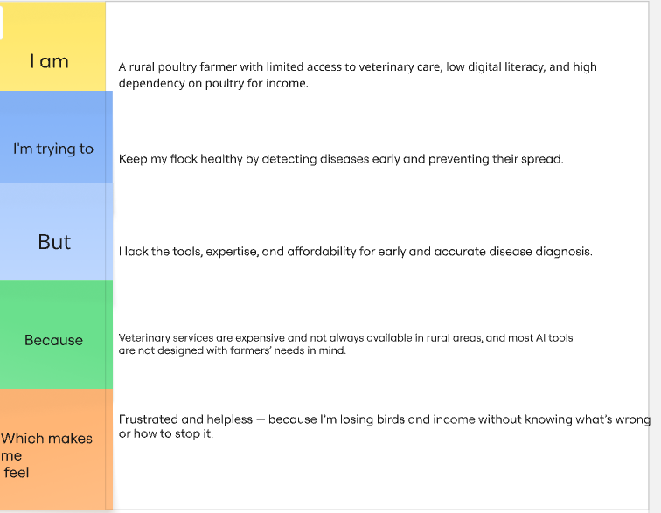

Reference: <https://miro.com/templates/customer-problem-statement/>

**Example:**

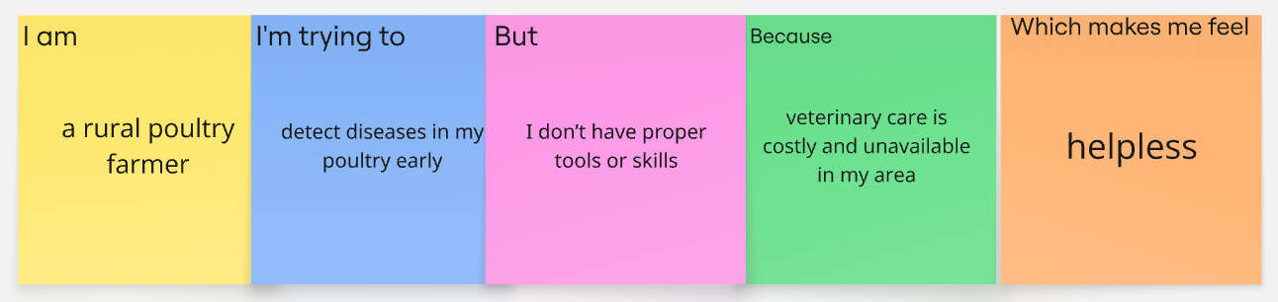

|  |  |  |  |  |  |  |  |
| --- | --- | --- | --- | --- | --- | --- | --- |
| **Problem Statement (PS)** | **I am (Customer)** | **I’m trying to** | **But** | **Because** | **Which makes me feel** |  | |
| a rural poultry farmer | detect poultry diseases early | I don’t have the tools or knowledge | veterinary services are expensive and hard to access | helpless and worried | helpless and worried | |
| a farmer managing many chickens | a farmer managing many chickens | keep my flock healthy and avoid loss | I can't identify symptoms accurately | there’s no affordable or accessible diagnostic tool available | frustrated and unsure | |